Title of the Paper:- Font Size 22, Bold, Centre Aligned, Title Case
Author(s): Font size 12,Bold,Italic, Centre Aligned,
Affiliations: Font Size 12, Bold,Italic, Centre Aligned,
e-mail ID: sudagar19@gmail.com(Font Size 12, Bold,Italic, Centre Aligned)

ABSTRACT : (Font 11 and Bold, Italic, Space Single Line)
This present work deals with the synthesis, characterization and anti-inflammatory activity of some novel thiazole-thiadiazole derivatives. 2-amino 4-phenyl thiazole (I) was prepared by triturating thiourea and iodine and mixed with substituted acetophenone. Equal mole of (I) & phenylisothiocyanate in the presence of potassium hydroxide, at room temperature afforded 1-phenyl-3-(4-phenylthiazol-2-yl)thiourea(II). When (II) was directly reacting with hydrazonoyl chloride in refluxing ethanol in the presence of triethylamine afforded 4-substituted phenyl tiazol-2-imine-3,5-diphenyl thiadiazole derivatives(III). The chemical structures of synthesized compounds were confirmed by MASS, FTIR and ¹H-NMR spectral studies. The synthesized compounds were (50µgm/kg) screened for anti-hypertensive activity by Tail Cuff method.
Keywords: Anti-hypertensive activity, Tail Cuff method, Thiazole, Thiadiazole.

I.INTRODUCTION

Now the Full Text follows (Font Size 11,Times New Roman), starting with the Heading “INTRODUCTION”, centre aligned, Bold. All Headings are in upper case with bold,central alignment words in Font 11. Headings can be numbered in ROMAN Numerals. Leave single spaces between the number and the heading. Do not number CONCLUSION, ACKNOWLEDGEMENT and REFERENCES. All subheadings are left aligned.Refrence font size is 9.Page layout top 0.8”,bottom 0.8”,left 0.62”, right 0.62”.Single spacing of all content.

The importance of thiazole and thiadiazole nucleus is well established in the field of pharmaceutical chemistry. This class of compounds has played a pivotal role in organic and medicinal chemistry. Various pharmacological activities such as antihypertensive, antidiabetic and anti bacterial are associated with compounds having thiazole and thiadiazole nucleus.

II. EXPERIMENTAL WORK

The melting range of the synthesized compounds was performed by LAB-INDIA MS-VIS Visual melting point apparatus and is uncorrected.
STEP-1: General procedure for the synthesis of Substituted 2-amino-4-phenyl thiazole derivatives (I).
Substituted 2-amino 4-phenyl thiazole (I) was prepared by triturating thiourea (0.2 mol) and iodine (0.1) and mixed with substituted (0.1mol) acetophenone. The mixture was heated on a water bath with occasional stirring for 8 hrs to get the product. The obtained solid was washed with diethyl ether to remove unreacted substituted acetophenone. The crude product was dissolved in hot water and filtered to remove the sulphone. Substituted 2-amino-4-phenylthiazole substituted derivatives were precipitated by the addition of ammonia to the above filtrate and re-crystallized from ethanol has resulted white solid, yield 70% m.p 238ºC. Which was purified by column chromatography on silica gel (toluene: ethyl acetate: formic acid) to give the required 2-amino-4-phenyl thiazole.
STEP-2: Synthesis of substituted 1-phenyl-3-(4-phenylthiazol-2-yl)thiourea(II)
Reaction of 4-phenyl 1,3-thiazol-2-amine derivative(I) with phenylisothiocyanate in dimethylformamide, in the presence of potassium hydroxide, at room temperature afforded 1-phenyl-3-(4-phenylthiazol-2-yl)thiourea(II)
STEP-3: Synthesis of substituted 4-substituted phenyl tiazol-2-imine-3,5-diphenyl thiadiazole derivatives(III)
The reactivity of the disubstituted thiourea derivative II with various types of hydrazonoyl chlorides was evaluated. Thus, treatment of the disubstituted thiourea derivative II with the hydrazonoyl chloride in refluxing ethanol in the presence of triethylamine afforded 4-substituted phenyl tiazol-2-imine-3,5-diphenyl thiadiazole derivatives(III).
The IR spectrum studies of the synthesized compound were recorded by pressed-pellet technique. IR spectra were recorded in KBr press (Shimadzu). H-NMR-Bruker avance 300MHz using TMS as internal standard.

Fig.1. LAB-INDIA MS-VIS Visual melting point apparatus and is uncorrected.
III.RESULTS AND DISCUSSION

The synthesized compounds were screened for anti-hypertensive activity on Albino normotensive rats (Wistar Strain) by Tail Cuff method.
Pharmacological evaluation:

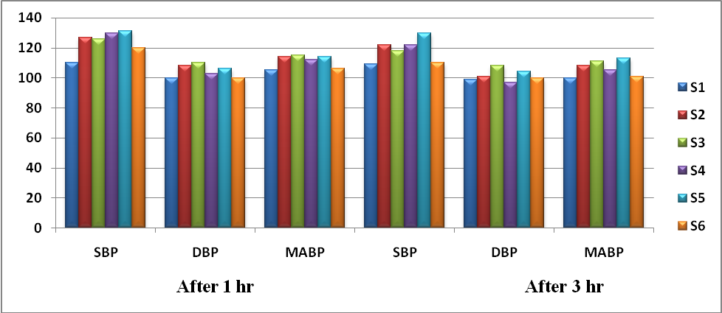

Fig.2: Reduction in blood pressure (mm Hg) at a dose of 50µgm/kg animal body weight.

CONCLUSION
In conclusion, the present study highlights the importance of thiazole-thiadiazole derivatives for rational drug designing for various diseases. And therefore serves as lead molecules for further modification (molecular modeling) to obtain clinically useful entities. On the basis of predicted biological activity spectra, new lead structures were discovered with antimicrobial, antifungal, antiviral and anti-diabetic, anti-inflammatory activities etc.,

REFERENCES
- Sunny Jalhan, Anil Jindal, Avneet Gupta, Hemraj, Synthesis, biological activities and chemistry of thiadiazole derivatives and schiff bases; Asian Journal of Pharmaceutical and Clinical Research; Vol 5, Issue 3, 2012, 199-208.
- Nadeem Siddiquia, Priya Ahuja, Waquar Ahsan, S. N. Pandeya, M Shamsher AlamaThiadiazoles: Progress Report on Biological Activities, Journal of Chemical and Pharmaceutical Research 2009, 1(1):19-30.
- Manjoor Ahamad Syed, Alagwadi Kallanagouda Ramappa, Shanker Alegaon, Synthesis And Evaluation of Antitubercular And Anti Fungal Activity Of Some Novel 6-(4-Substituted Aryl)-2-(3,5-Dimethyl-1h-Pyrazol-1-Yl) Imidazo[2,1-B] [1,3,4] Thiadiazole Derivatives; Asian J Pharm Clin Res, Vol 6, Suppl 3, 2013, 47-51.
- Sunayana Ghodgaonkar, Vaibhav .V.Kulkarni, Sandeep. O.Waghulde, Sachin .S. Laddha Jinish Shah; Synthesis and Evaluation of Novel Thiazole Derivatives; Synthetic Organic Chemistry, 1-30 nov 2010.
- Andanappa K. Gadad, Malleshappa N, Noolvi, Rajshekhar V. Karpoormath. Synthesis and antitubercular activity of a series of 2-sulfonamido/trifluoromethyl-6-(40-substitutedryl/heteroaryl)imidazo[2,1-b]-1,3,4-thiadiazole derivatives. Bioorganic Med Chem. 2004;12: 5651-59.
- Cherkupally Sanjeeva Reddy, Lade Sanjeeva Rao, and Adki Nagaraj. Synthesis and Evaluation of Novel Bis[1,2,4]triazolo[3,4-b][1,3,4]thiadiazoles as potent antimicrobial agents. Acta Chim. Slov. 2010;57: 726-32.
- Divyesh Patel and Arun singh, Synthesis, Charaterization and Antimicrobial activity of metal chelates of 5-[4-Chlorophenyl (1,3,4)thiadiazol-2-ylaminomethylene]-8-hydroxy quinoline. E-Jour Chem. 2009; 6(4):1017-22.
- Srinivas Ampati, Raju Jukanti, Vidya Sagar, Rama Ganta, Sarangapani Manda, Synthesis and in vivo anti-inflammatory activity of a novel series of benzoxazole derivatives; Pelagia Research Library, Der Chemica Sinica, 2010, 1 (3): 157-168.
- Reshma J. Nevagi, Biological and medicinal significance of 2-aminothiazoles; Scholars Research Library, Der Pharmacia Lettre, 2014, 6 (5):134-150.
- Arvind k. Singh, Geeta Mishra and Kshitiz Jyoti, Review on Biological Activities of 1,3,4-Thiadiazole Derivatives; Journal of Applied Pharmaceutical Science 01 (05); 2011: 44-49.
- S.K.Srivastava, Smita Verma,and S.D.Srivastava. Synthesis, Charecterization and biological activity of 1,3,4-thiazolidin-4-one derivatives of 2-mercapto-5-methyl-1,3,4-thiadiazole. J.Chem.Pharm.Res., 2010;2(5): 270-276.

